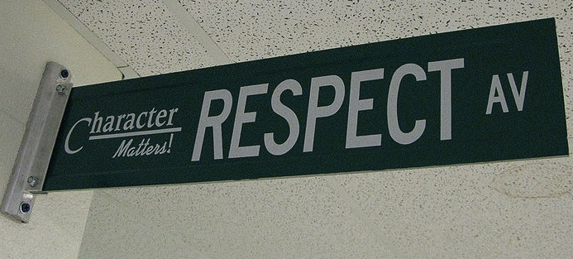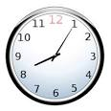

#### Follow the

#### CHAMPS Expectations!!

#### Raise your hand and wait to be called on before speaking.

#### Be Respectful.

Welcome to 8th grade Language Arts. Our goal for the year is to foster a love for reading and to learn the importance of becoming powerful writers, we will exam texts through a writer’s eye. We will be reading and writing poetry, narratives, informational, and argumentative texts. You will have the opportunity to read engaging, thought- provoking texts and novels.

By examining these exemplary texts, you will build your skills as a writer and be able to communicate your ideas more effectively. We will also spend time building your vocabulary skills. Discussion, both speaking and listening, as well as working in collaboration with others will play a large role in class and help to prepare you for the “real” world. I look forward to spending the year learning with you!

# Course Description

Homework is not busywork; and from time to time, homework will be necessary for you to complete in order to participate in class the next day or to develop important skills. As your Language Arts teacher nothing makes me happier than to see my students reading and really loving it that being said as my student I do have the expectation that you read a grade appropriate novel of your choice.

Homework assignments may include, but are not limited to:

* Independent reading
* Drafting, revising, and writing polished pieces of writing
* Vocabulary activities
* Responding to blog posts or writing prompts

## Homework

### Class Expectations

All school rules also apply.

#### Arrive on time & be prepared.

8th Grade English Language Arts

**Students will follow C.H.A.M.P.S. for classroom expectations!**

**C**onversation - students learn conversation levels expected during class.

**H**elp – students learn how to get the teacher's attention and their questions answered?

**A**ctivity – students will know what is expected during classroom activities.

**M**ovement – students will know what move-ment is expected during different classroom activities.

**P**articipation -students will know how they are expected to participate during class.

**S**uccess – students will be successful by following the expectations!

## Grading Weights

Major Grades (Exams, Projects) – 50 percent

Daily Grades, and Homework - 30 percent

Quiz Grades - 20 percent

Final Exams - 20 percent

**YOU WILL NEED:**

* A composition book & folder to keep in the classroom
* Writing utensils (pens or pencils)
* Highlighter
* A positive attitude, and a sense of humor!

**Entering Class:** Gather any necessary materials, quickly find your seat, and begin working on the warm-up posted on the board. This is a timed five-minute activity.

**Bathroom Usage:** Schoolwide policy states students may not leave class in the first ten minutes. Students must sign out and have a hall pass whenever they leave the classroom.

**Food & Electronic Devices:** Food and drink are not permitted outside of the cafeteria. Electronics should not be seen or heard in the classroom.

**Exiting Class:** In the last few minutes of class, you will wrap up what you are working on, return materials to the appropriate locations, and complete an exit ticket. The teacher, not the bell, dismisses you upon completion of these tasks.

**Absences:** If you are absent, it is your responsibility to make up missed assignments. See the “While You Were Out Folder” for what you missed.

## Classroom Policies, Procedures, & Grading